Glass-Free 3D Monitor
User Guide
v1.3

Revisions
Version | Date | Author | Revision
V1.0 | 2019-5-23 | Weixiang Zhang | Create document
V1.1 | 2019-5-24 | Weixiang Zhang | Add tracker component
V1.2 | 2019-10-19 | Weixiang Zhang | Update software UI
V1.3 | 2020-05-14 | Weixiang Zhang | Update mount installation

Content
1 PC Requirements 4
2 Hardware 4
2.1 Interface 4
2.2 Base Installation 5
2.3 USB Connection 6
3 Software Installation 6
3.1 Camera Driver 6
3.2 USB Driver 7
3.3 Glass-Free 3D Player 8
3.4 Glass-Free 3D Controller 8
4 Software Usage 8
4.1 Glass-Free 3D Controller 9
4.2 Glass-Free 3D Player 9
5 FAQ 10
5.1 Glass-Free 3D Controller hangs or crashes 10
5.2 Bad performance of eyes tracking 11
5.3 Monitor power off 11
5.4 Display side-by-side content 11

PC Requirements
For full functions usage, the PC configuration must meet following requirements.
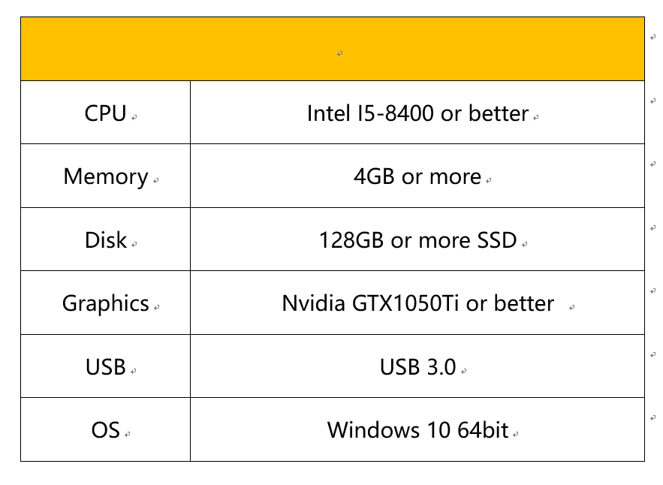

Hardware

Interface
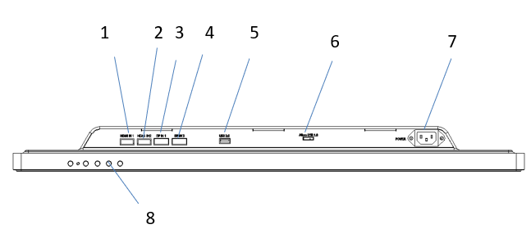
- HDMI 2.0 Input
- HDMI 2.0 Input
- DP 1.2 Input
- DP 1.2 Input
- USB 2.0
- Micro USB 3.0
- 22V Power
- Keys

Base Installation
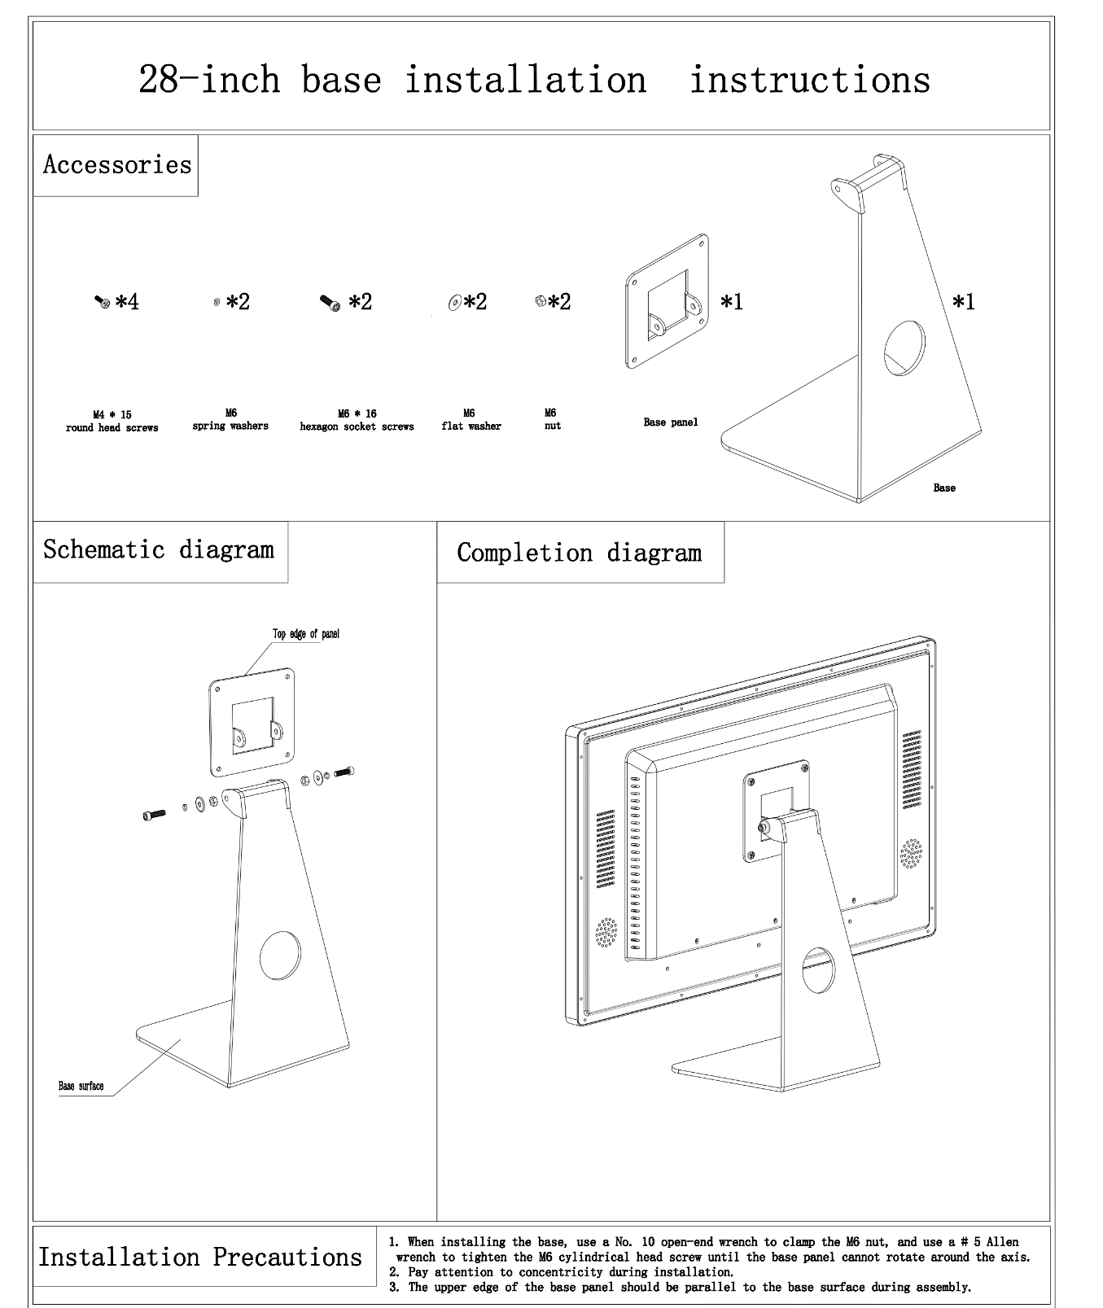

USB Connection
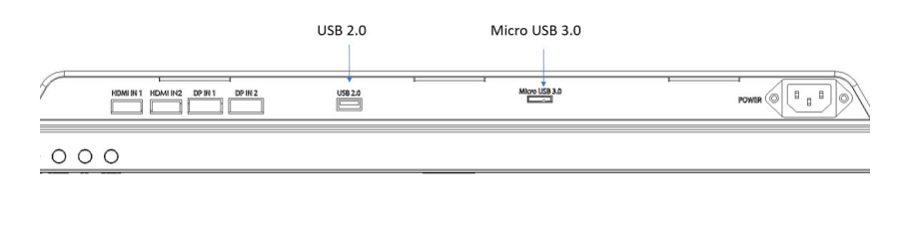
Connect the USB 2.0 port to PC USB2.0 port and Micro USB 3.0 port to PC USB 3.0 port.

Software Installation

Camera Driver
Open the Camera Driver directory in the downloaded software packages and run “intel_rs_dcm_sr300_3.3.27.5718.exe” to install camera driver and then run “intel_rs_sdk_offline_package_10.0.26.0396.exe” to install SDK. Keep all the options as default during installation.
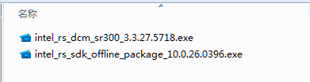
Figure 3

After installation, following steps to check if camera works fine.
  - Open “Intel RealSense SDK Gold” directory in Windows Desktop.
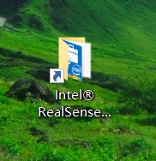
Figure 4
  - Run “Intel RealSense SDK Sample Browser”
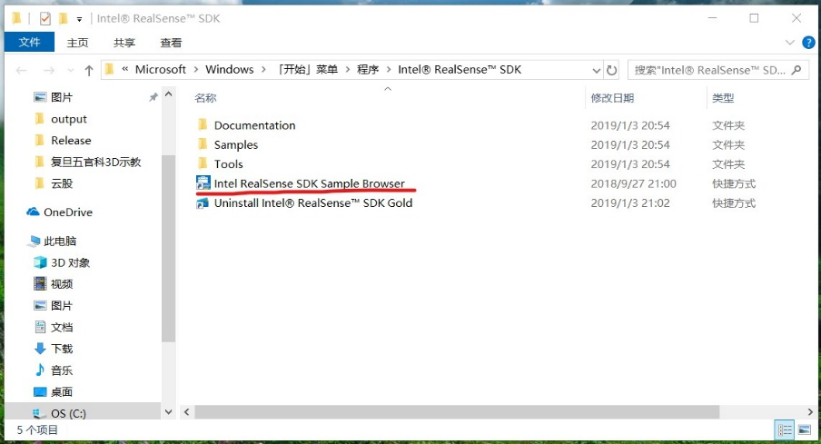
Figure 5
  - Click “Tools” tab and run “Camera Explorer”
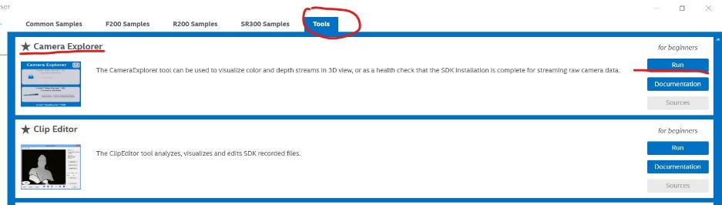
Figure 6
  - If you can camera information, as illustrated in Figure 7, then it works.
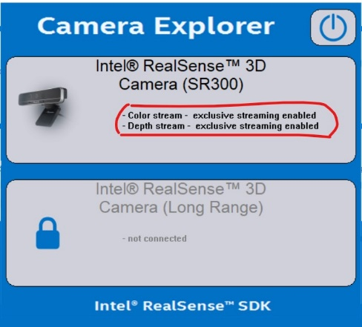
Figure 7

USB Driver
Open the USB Driver directory in the downloaded software packages and run the installer. Click the 1st button to install, as illustrated in Figure 8.
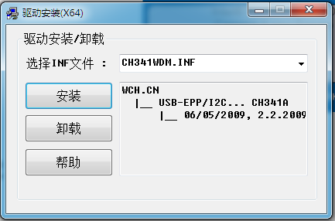
Figure 8

Glass-Free 3D Player
Open the Player directory in the downloaded software packages and run the installer.
Keep all options as default during installation, after finished a shortcut is created on Windows Desktop, as illustrated in Figure 8.
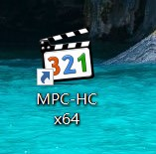
Figure 8

Glass-Free 3D Controller
Open the Glass-Free 3D Controller directory in the downloaded software packages and run the installer. Keep all options as default during installation, after finished a shortcut is created on Windows Desktop, as illustrated in Figure 9.
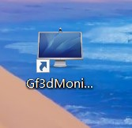
Figure 9

Software Usage
Following the below sequence to start the software.

Glass-Free 3D Controller
To experience Glass-Free 3D effect, the Glass-Free 3D Controller application MUST be running. Find and click the shortcut on Windows Desktop to start the controller application, as illustrated in Figure 12.
Figure 12

After running, there are two windows, one is command window and the other is camera preview window. In camera preview window, if there are two red circle on eyes, then the user is tracked and the tracked user will get the best Glass-Free 3D effect, as illustrated in Figure 13.

Click START button to start.
Hotkey CTRL + ALT + M is registered to switch between 2D mode and 3D mode.
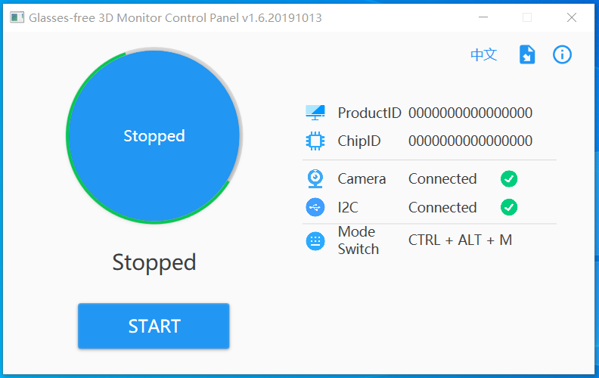
Figure 13

Glass-Free 3D Player
Click the shortcut on Windows Desktop to start the player, as illustrated in Figure 14.
Figure 14

When start, the main UI is as below. You can drop a video file to play or drop files into playlist, as illustrated in Figure 15.
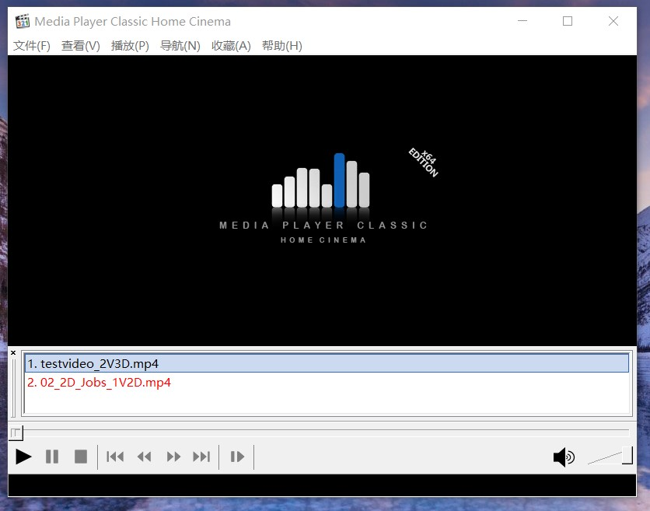
Figure 15

This player is customized to detect file format automatically according to a specified suffix in file name. You can follow the rules to rename video file.
Video Type | Name Suffix | Examples
Normal 2D video | _1V2D or add nothing | Jobs_1V2D.mp4
Side-By-Side 3D video | _2V3D | Avatar_2V3D.mp4

For example, when play a video Avatar_2V3D.mp4, player detects the suffix _2V3D and when user double click to enter full-screen mode, player will send command to switch to 3D mode and switch back to normal 2D mode when exit from full-screen mode.

Note:
please keep the file name simple only with English characters and number, better not to use SPACE。

FAQ

Glass-Free 3D Controller hangs or crashes
Please make sure monitor’s two USB ports are well connected with PC USB 3.0 ports.
Please don’t use very long USB extension cable which may cause power lost.

The application is still in beta stage, if encounter some issues, please try to restart the application or restart the PC.

Bad performance of eyes tracking
To get the best eyes tracking performance
- Use monitor in a place with enough illumination.
- User should sit in front of monitor in 30 degree and in 70cm to 100cm, as illustrated in Figure 17.
- Don’t cover face with mask or hat.
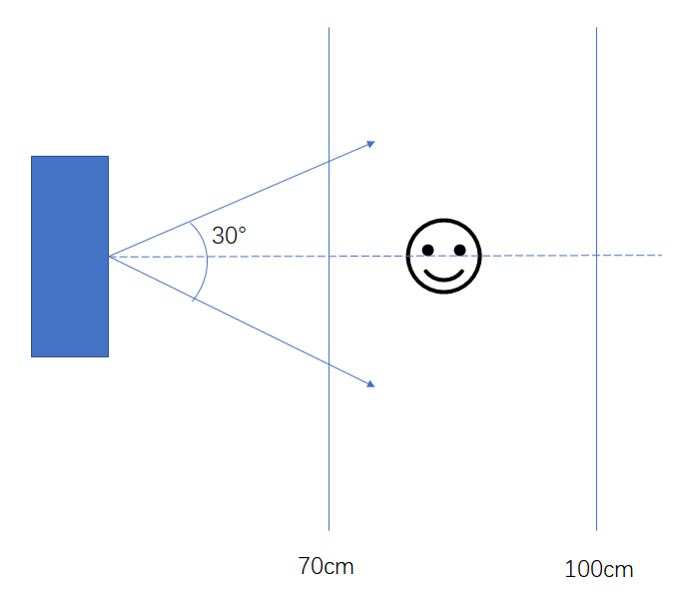
Figure 17

Monitor power off
When there is no signal input, the monitor will power off.

Display side-by-side content
Please make sure all cables are well connected.
Please check if the Glass-Free 3D controller is running, as illustrated in chapter 4.1.

