2017—2018学年度第一学期期中
初二年级英语试卷
命题人：亢敏 雷悦 审核人：亢敏

听力部分（20分）
I. 根据所听到的内容，选择相应的图画.(5分)
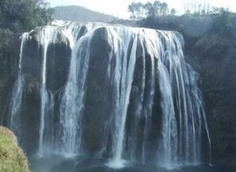
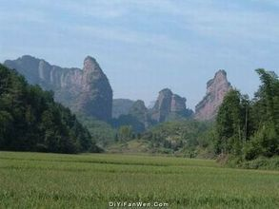
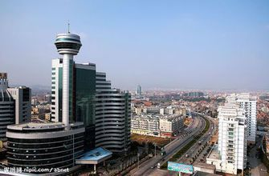
（ ）1.

A B C
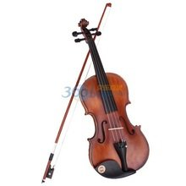
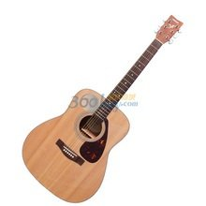
（ ）2.
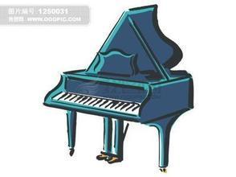

A B C
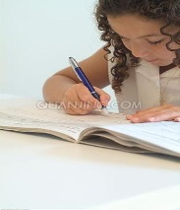
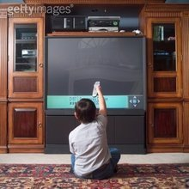
（ ）3.

A B C
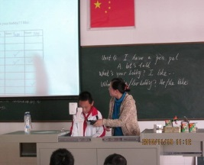
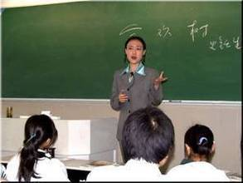
（ ）4.

A .math B . Chinese C .English

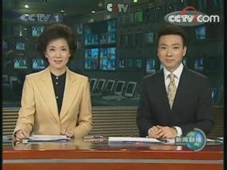
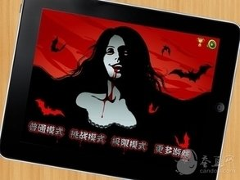
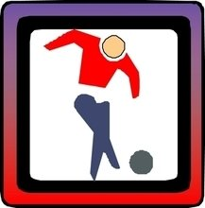
（ ）5.

A B C

2. 对话理解，听下面的对话，从A.B.C三个选项中选出最佳答案（10分）

（ ）6.Where did Ben go on vacation?
- To New York B. To London C. To Beijing
（ ）7.What lesson does Lucy have this Sunday morning?
A.A tennis lesson B. A dance lesson C. A guitar lesson
（ ）8.What color is Kate’s skirt?
A.Yellow B.Red C.Black
（ ）9.What’s the best in the restaurant?
A.The food B.The service C.The floor
（ ）10.What did Jean watch yesterday evening?
- A comedy B.A talent show C.An action movie
（ ）11.Who went to Shanghai last month?
A.Jim B.Mary C.Jim’s parents
（ ）12.How many soap operas did Mary watch?
- One B. Two C. Three
（ ）13.Where is Ted from?
A.India B.America C.Australia
（ ）14.How does Ted go to school every day?
A.He runs B.He walks C.He rides his bike
（ ）15.When does Ted usually arrive at school?
A.At about 7:00 B. At about 7:20 C. At about 7:40
II. 笔录要点,根据你所听到的内容,填写下面的表格,每空不超过三个单词 (5分)
Alice’s Sunday
She went to her uncle’s 16__________________ with her parents
In the morning | She helped her uncle 17__________________
In the afternoon | She 18_________ with her cousin Jack
In the evening | She ate 19_________，eggs and fish for dinner
After dinner | She went home by 20__________

笔试部分（80分）
I．单项选择（每小题1分，共20分）
( ) 21． The twins＿＿＿＿＿＿in Dalian last year．They＿＿＿here now．
A． are; were B． were; are C． was; are D． were; was
( ) 22．＿＿＿＿your father at work the day＿＿＿＿＿yesterday(前天）﹖
A． Was; before B． Is; before C． Was; after D． Is; after
( ) 23. I came _______ my house two days ago .
A. back on B. back to C. to back D. back
( ) 24 . _________? He did some reading at home.
A. What does your father do yesterday evening
B. What does your brother do in the school
C. What did your brother do over the weekend
D. Where did your brother go last Sunday

( ) 25. The koala sleeps _______，but gets up _________.
A. during the day; at the evening B. at day ;during night
C. in the day ;during the evening D. during the day ; at night
( ) 26. We had great fun _________ in the water.
A. to play B. played C. playing D. play
( ) 27. -- ______ is “Lucky 52” shown on CCTV-2? --Every week.
A. How often B. How long C. How soon D. How many times
( ) 28. Eating fruit and vegetables can help you ______ more vitamins
A. got B. getting C. to get D. gets
( ) 29. Life in the country is quite _______ that in the city.
A. the same B. different from C. full of D. the same as
( ) 30. ________ your father __________ game shows?
A. What do, think of B. What are, think
C. What does, think of D. What is , think
( ) 31. Mother often ______ me ______ my homework after supper.
A. makes, doing B. lets, doing C. watched, to do D. makes, do
( ) 32. “ Could you please give me some advice?” “__________.”
A. That’s all right B. Yes, please C. It doesn’t matter D. Of course
( ) 33. Kate isn't very ______.She likes to stay at home and read.
A．outgoing B．kind C．funny D．quiet
( ) 34．______ should win，Jane or Mary?
A．Who do you think B．Whose do you think
C．Do you think whose D．Do you think who
( ) 35.This picture is ____from that one,can you tell the ____between them?
A．different；differences B．differences；different
C．different；different D．differences；differences
( ) 36. The house is _______ small for a family of six.
A. much too B. too much C. very much D. so
( ) 37.Through the window we can see nothing but _______ buildings.
A. tall very many B. very many tall
C. very tall many D. many very tall
( ) 38. --What's your brother like? --He is_______.
A. a driver B. very tall C. my friend D. at school
( ) 39. The jacket was so_______ that he decided to buy it.
A. much B. little C. expensive D. cheap
( ) 40. Our classroom is________ larger than theirs.
A. more B. quite C. very D. much
II、完形填空（每小题1分，共10分）
Every one of us, rich or poor, should at least have one or two good friends. Your friends will listen to you when you 1 , will take care of you when you are 2 , and will be together with you in your journey 3 life.Everyone needs friends. Friendship can make us 4 . 5 can we find a good friend and get on well with each other? Here is some advice.
★ Make friends with a person who is 6 to get along with.
★ Make friends with a person who has something in common with you.
★ Give your friend a hand when he or she is 7 . Friends should always be ready to 8 each other.
★ 9 the best friends may have quarrel (争吵) sometimes. If this happens, don’t let your quarrel last too long. Try to make up with(和好) your friends soon.
Friendship is a kind of treasure in our life. It 10 a bottle of wine, the longer it is kept, the better it will be.
( ) 41. A. say B. speak C. tell D. talk
( ) 42. A. sick B. happy C. popular D. shy
( ) 43. A. with B. of C. across D. through
( ) 44. A. quieter B. smarter C. happier D. easier
( ) 45.A. What B. How C. When D. Where
( ) 46.A. easy B. hard C. impossible D. different
( ) 47.A. in trouble B. in schools C. in practice D. in mind
( ) 48.A. hit B. hurt C. help D. touch
( ) 49.A. Sometimes B. Ever C. Even D. Always
( ) 50.A. look like B. likes C. look likes D. is like

III、阅读理解（每小题2分，共20分）
A
Boonie Bears  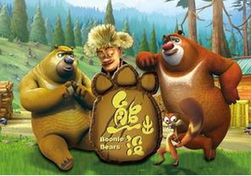  《熊出没》  It is a Chinese animated cartoon. It was first shown (上映) in February 2012, and it is very popular with children in China. | Name:  Bramble 熊二  Character:  dull (呆头呆脑的), lazy  Family:  his brother Briar  Likes:  eating all kinds of delicious food and sleeping
Name:  Briar 熊大  Character (个性): smart  Family:  his brother Bramble  Likes:  making fun of Logger Vick  stealing fruit from Logger Vick  destroying Logger Vick’s home  protecting (保护) the forest | Name:  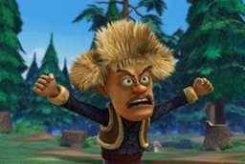  Logger Vick 光头强  Character:  tricky (狡猾的)  Job:  cutting trees in the forest  Favorite saying:  If you make me angry, I will hit you anyway.
( ) 51. Boonie Bears is from ______.
A. America B. England C. China D. Australia
( ) 52. Boonie Bears was first shown in______, 2012.
A. January B. February C. March D. April
( ) 53. Briar is______.
A. lazy B. tricky C. smart D. dull
( ) 54. Bramble likes______.
A. eating delicious food B. destroying the forest
C. stealing fruit D. playing with Logger Vick
( ) 55. Which of the following is TRUE?
A. Logger Vick is a dull person.
B. Logger Vick always does something good.
C. Briar and Bramble work for Logger Vick.
D. Boonie Bears is popular with children.

B
What I Like Most about My Best Friend
Lily Chen, Taiwan
Kay is the most confident girl that I have ever met. Although she looks tough, she is really kind. It may surprise some people to find out Kay and I are best friends, because we have different personalities. I’m not confident and I am very shy, which is the opposite if Kay, but I think this is why we are such good friends.
Alan Cordoba, Mexico(墨西哥)
My best friend is Fanny, my girlfriend. I can always depend on her. We always take care of each other. The first week we met. I got sick with flu and she came to my house to take care of me every day. She is also very smart and interesting, although sometimes she gets angry. She shouts at me for always being late.
Isabel Famosa, Cuba（古巴）
My best friend is Ana Hernandez. She is honest, kind and sensitive(敏感的). We were born in the same city in Cuba. We spent a lot of time together until we were 12. Then, I moved to America with my family and thought that I would never see Anna again. When I went to college in New York, Anna had a room in the same building. She now lives near me in New Jersey and we see each other all the time.
Ken Ichigawa, Japan（日本）
I love to spend time with Daisuke because he makes me laugh so much. He’s very funny. We share the same sense of humor(幽默感), and know how to make each other cry with laugher. We enjoy talking the funny things we did when we were children, and tell the stupid jokes over and over again.
( ) 56. Kay’s personality is______ than Lily Chen’s.
A. tougher B. shyer C. more confident D. kinder
( ) 57. In Paragraph 2, the girl friend gets angry sometimes______.
A. when they have different opinions
B. when the boy friend doesn’t keep the time
C. because the boy friend needs to be looked after
D. because the boy friend is not intelligent and interesting
( ) 58. In Paragraph 3, which of the following is NOT TRUE?
A. The two girls were born in the same city.
B. The two girl left when they were 12
C. The two girls met and lived away from Cuba.
D. The two girls met because they kept looking for each other
( ) 59. In Paragraph 4, they become good friends______.
A. because of the funny things they did together
B. because of the same interest and sense of humor
C. because they love stupid jokes
D. because they grew up together
( ) 60. What is mentioned in Ken’s description?
A. Moving to the USA with parents.
B. Enjoying talking about funny things.
C. Studying in the same school.
D. Getting angry sometimes.

IV．用方框中所给词的适当形式补全短文（每小题1分，共10分）
walk, hold, hard, strong , bright, make, with, try, soon , see
The sun says he is stronger than the wind. The wind says he is stronger than the sun.A man is (1) down the street (2) a hat and coat on. The sun says, “Let’s (3) who can (4) the man take off his hat and coat. If you can do that, you are (5) than me.”
Now the wind begins to blow. But the (6) he blows, the tighter(更紧地) the man (7) his hat and coat. The wind can’t make the man take off his hat and coat. Now the sun (8) . He shines brightly. (9) the man takes off his hat. Then the sun shines (10) , and the man takes off his coat.
So the wind says, “That’s all. You are stronger than me.”
61.__________ 62. __________ 63. _________ 64. __________ 65. _________
66.__________ 67. __________ 68. _________ 69. __________ 70. _________

V．用所给单词的适当形式填空（每小题1分，共5分）
71. We__________ (decide) to go to the beach.
72. It’s not easy for me __________ (make)friends.
73. Lisa sang _______________(clear) than Nelly.
74. How about ________________ (listen) to the radio tonight?
75. I enjoy ________________ (watch) TV on Saturday evenings.

VI．从方框中选出适当的选项补全对话（每小题1分，共5分）k

A. What else do you like about him?
B. Do you think he’s a lot like you?
C. He’s good at sports.
D. No, it isn’t.
E. Who is your best friend?
F. What does Mike look like?
G. H’s more outgoing and athletic than me

W: Dave, is that your best friend Mike?
M: (76) It’s Tony.
W: (77)
M: He’s tall and has black hair. Tony is shorter than him.
W: (78)
M: I don’t think so. We are very different.
W: What are your differences?
M: (79)
W: Are you quieter than him?
M: Yes, I am. He talks more than me.
W: (80)
M: Well, he’s funny and friendly to others.
（76）_________（77）_________（78）_________（79）_________（80）_________

VII. 书面表达。（共10分）
《同步学习周报》正在联袂阳光中学举行“我的好友我来谈”活动。请你根据下表中提供的信息, 写一篇短文介绍你和你最好的朋友Nancy的相同之处和不同之处。
要求：
1、包括信息中提及的所有内容，语句通顺，条理清楚。
2、字数80个词左右（开头已经给出，不计入总词数）, 可适当加以发挥。

人物 | 不同点 | 相同点
Nancy | 1、比我高得多, 更外向  2、更擅长唱歌、跳舞  3、喜欢去听音乐会 | 1、喜欢运动  2、学习努力, 各门功课都学得好  3、喜欢阅读, 通常在周末一起去图书馆
I | 1、喜欢上网  2、喜欢旅游
对朋友之间的异同点的看法：……（至少两点）
Nancy is my best friend. In some ways, we are the same.

