西安市第七十一中学2018-2019学年度第一学期期中考试
密
封
线
内
不
得
答
题
班 级
姓 名
考试号
座位号
班 级
姓 名
考试号
座位号
九年级英语试题
亲爱的同学：
欢迎你参加本次考试！请仔细审题，积极思考，细心答题，发挥你最好的水平。
温馨提示：
1.全卷共8页，满分100分，考试时间120分钟。
2.本卷的所有答案均写在答题卷上，做在试卷上无效。
第一部分 听力（20分）
一、听力（20分）
A) 听下面10段对话。每段对话后有1个小题，从题中所给的A、B、C三个选项中选出最佳选项。听完每段对话后，你都有10秒钟的时间来回答有关小题和阅读下一小题。每段对话读两遍。
( )1.What does Miss Black teach?
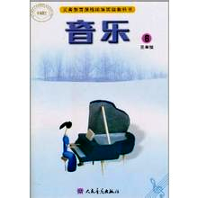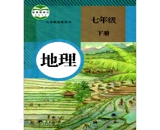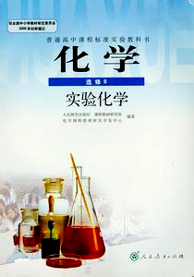
( )2.Where does Tom’s mother work?
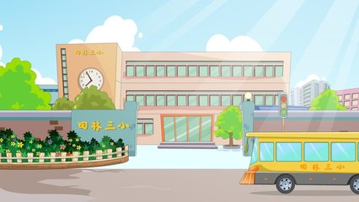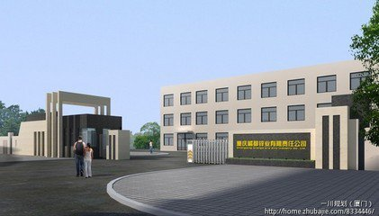
( )3.What is Peter’s animal sign?
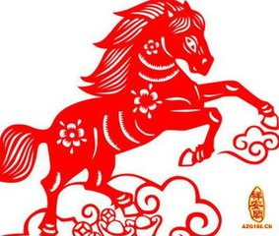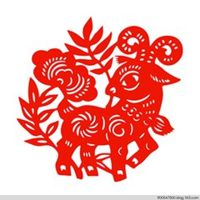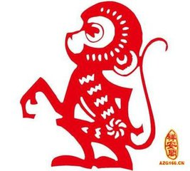

( )4.Why is David so sleepy?
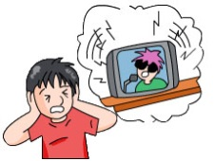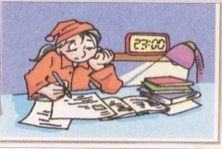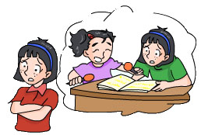
( )5.What does Millie usually do?
A. Dancing. B. Singing. C. Reading.
( )6.What is Miss Green like?
A. Creative. B. Active. C. Organized.
( )7.What does the man mean?
A. Nobody can do the best. B. Do as well as you can.
C. It’s difficult to do something perfectly.
( )8.What are they doing now?
A. They are eating bread. B. They are making sandwiches.
C. They are going shopping.
( )9.How much is the white shirt?
A. 20 yuan. B. 40 yuan. C. 80 yuan.
( )10.Why do some teenagers feel stressed?
A. They have too many exams. B. They have too much homework to do.
C. They don’t know how to make friends with others.

B) 听对话或独白。每段对话或独白后有几个小题，从题中所给的A、B、C三个选项中选出最佳选项。听每段对话或独白前，你将有时间阅读相关小题，每小题5秒钟。听完后，每小题你仍有5秒钟的时间来选择你认为最合适的答案。每段对话或独白读两遍。
听第一段对话，回答第11—12小题。
( )11. What does Tony’s father do?
A. A doctor. B. A teacher. C. A designer.
( )12.Where does Tony’s sister work?
A. In a big hospital. B. In a village. C. In a town.
听第二段独白，回答第13—15小题。
A few tips to help you be happy
密
封
线
内
不
得
答
题
First | Enjoy the simple things, such as reading a good book, 13 , or spending time with close friends.
Another | Be 14 , such as doing sports.
Finally | Help others, such as helping friends or the elderly, or 15 .
( )13.A. climbing the mountains B. playing the piano C. listening to music
( )15. A. doing some housework B. donating some money C. doing sports
听第三段独白，回答第16—20小题。
( )16. When did the tigers run out of the zoo?
班 级
姓 名
考试号
座位号
A. Last Sunday. B. Last Wednesday. C. Last Friday.
( )17. Where did two of the tigers go?
A. To the hills far away. B. To the hills nearby. C. To an old woman's house.
( )18. Why wasn't the old woman afraid of the tiger?
A. Because she didn't know it was a large animal.
B. Because she liked playing with tigers.
C. Because there was something wrong with her eyes.
( )19. What did the tiger do after it jumped into the house?
A. It soon went to sleep. B. It killed the old woman. C. It walked into a cage.
( )20.Where did the zoo keepers catch the tiger at last?
A. Outside the old woman's bedroom. B. On some old clothes. C. In the kitchen.

第二部分 笔试（80分）
二、 完形填空 （本题有15小题，每小题1分，共15分)
阅读下列短文，然后从各小题所给的A、B、C、D四个选项中选择一个最佳选项。
The situation seemed hopeless.
From the first day he entered my junior-high classroom, Willard P. Franklin lived in his own 21 , shutting out his classmates and me, his teacher. I tried to build a 22 relationship with him but he showed no interest. Even a “Good Morning Willard” received only a grunt(咕哝) that couldn’t be 23 . Willard was a loner(孤独的人) who seemed to have no hope or need to break silence.
Shortly after the Thanksgiving holiday, we received the news of the annual(每年的) Christmas collection of money for the 24 people in our school.
“Christmas is a season of 25 ,” I told my students. “There are a few students in the school who might not have a happy holiday season. 26 donating our Christmas collection, you will help buy food, clothing and toys for these needy people. We start the collection tomorrow.”
When I called for the donations the next day, I discovered that 27 everyone had forgotten, except Willard P. Franklin. The boy dug deep into his pants pockets 28 he walked up to my desk. Carefully, he 29 two coins into the small box.
“I don’t need milk for lunch,” he said 30 . For a moment, just a moment, he smiled . Then he turned and walked back to his desk.
That night, after school, I took our 31 to the school principal. I couldn’t help 32 the incident(事件) that had taken place.
“I may be wrong, but I believe Willard might be getting ready to become a part of the world around him,” I told the principal.
“Yes, I believe it is 33 for him to get out of his own world,” he nodded. “And I think we can do something to have him 34 a bit of his world with us. I just received a 35 of the poor families in our school who most need help through the Christmas collection. Here, take a look at it.”
As I read, I discovered Willard P. Franklin and his family were the top names on the list.
( )21. A. class B. school C. world D .home
( )22. A. equal B. simple C. friendly D. common
( )23. A. seen B. heard C. found D. discovered
( )24. A. poor B. good C. sad D. rich
( )25. A. giving B. getting C. buying D.receiving ( )26. A. By B. With C. For D. On
( )27. A. mostly B. hardly C. almost D. simply
( )28. A. while B. so C. before D. as
( )29. A. threw B. dropped C. brought D. changed
( )30. A. angrily B. quietly C. patiently D. sadly
( )31. A. students B. classmates C. teachers D. donation
( )32. A. taking B. having C. sharing D. getting
( )33. A. hopeless B. hopeful C. difficult D. impossible
( )34. A. compare B. begin C. mix D. share
( )35. A. list B. note C. message D. letter

三、阅读理解（本题有15小题，共25分）
阅读下列短文，然后从各小题所给的A、B、C、D四个选项中选择一个最佳选项。
A
There are English tests, math tests and running tests in schools. Have you ever heard about a bicycle riding test? Several primary schools and middle schools in China are having this new test.
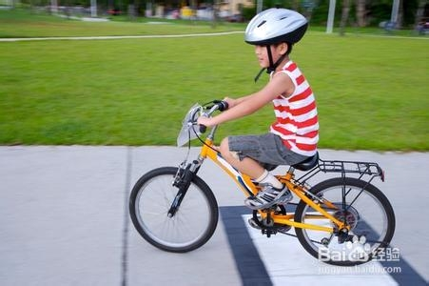
To raise students’ safety awareness(意识) on the roads, some schools are holding bicycle riding tests for students over 12 years old. The schools also give classes about traffic rules. Students can learn to ride a bicycle with the help of their teachers. Once they pass the test, they will get a “riding license”. Many students go to school by bicycle in China. Most students and parents welcome this new test.
密
封
线
内
不
得
答
题

( )36. It is a new ___________ test in this article.
班 级
姓 名
考试号
座位号
A. English B. bicycle riding C. running D. math
( )37. What students can have this new test?
A. 11-year-old students. B. over 10-year- old students.
C. more than 12-year- old students. D. middle school students.
( )38. Why are some schools holding bicycle riding tests?
B. To make students get a “riding license”.
C. To advise students to go to school by bicycle.
D. To make students have better safety awareness on the roads.
B
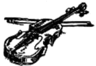
Just as I came back home. I heard a sound coming from the bedroom upstairs—it was from my favorite violin.
“Thief(小偷)！”
I rushed upstairs and saw a boy in dirty clothes pulling my violin down.
At first sight, I found a new pair of shoes missing. It seemed he was surely a thief.
However, when I saw his eyes full of fear, my anger disappeared. I smiled and asked, “Are you Mr. Ram’s student Rubens? I’m his butler(男管家). I’ve heard Mr. Ram say his student will come. It must be you.”
“Has my teacher gone out ?” the boy said, “I think I’d better visit him again in a while.”
I nodded and asked him, “Do you like playing the violin?”
“Yes, but I’m too poor to afford one.” the boy replied.
“Then, I’ll give you this violin.” The boy looked at me surprisingly, but he picked up the violin. While going out of the room, he suddenly saw a huge photo of me playing the violin at the Grand Theatre of Sydney on the wall. His face turned pale. He stood there for a moment and ran out. He must have understood what had happened because no master(主人)would put up the butler’s photo on the wall of his living room.
A few years later, at a music competition in Melbourne, I was invited to be the judge(评委). Finally, a violin player called Merritt won the first prize.
After the prize-giving, Merritt ran to me holding a violin box, his face red, and asked, “Mr. Brian, do you still know me? You gave me the violin, which I have treasured ever since! Today, I want to say sorry and give back this violin to you without regret…”
He was just the “Mr. Ram’s student”!
( )39. The writer felt ______ when he saw the boy pulling his violin down.
A. afraid B. angry C. sad D. disappointed
( )40. In fact, the boy was ________.
A. Mr. Ram’s student B. a visitor to the Ram family
C. the butler’s friend D. a thief to the writer’s home
( )41. The boy’s face turned pale probably because he realized_________.
A. the butler was a great musician B. he would be found as a thief soon
C. the master had come back home D. the butler was just the master
( )42. The passage mainly wants to tell us that _______.
A. It’s never late to say sorry
B. the future is what we make it
C. kindness can bring one power(动力)
D. success depends on trust and support(支持)
C
①The Dream It is everyone’s dream to work at home or not work at all．You can plan your own hours and work when you want to．There is no more rush hour and no hours that people waste when they get to and from a job every day．
②The Fact The fact is that this dream can be attained．You can stay at home，work when you want to and make money when you need to．There are plenty of opportunities for you to make money at home，just by using your computer and the Internet．
③Start Today! Educate yourself，look closely into all the opportunities and decide on what works best for you．It will not happen during one night，but you can make the decision today and start to make it happen today．
④How Could You Do It? Do you have a blog（博客）or a personal website like millions of other people? Are you using it to make money? Most of these blog and website owners are not．But you can do that!
⑤________________ When you have your computer and the Internet working for you，your businesses will be working for you 24 hours a day，seven days a week．You will make money while you sleep，travel or do whatever you want to do all day long．
⑥Get Going! There are many ways you can make money with your computer．And you can begin your Stay – at – home businesses with just a little money．What are you waiting for ?
( )43．In which part of a newspaper would you most probably read this passage?
A．Sports B．News C．Culture D．Business
密
封
线
内
不
得
答
题
( )44．What does the underlined word “attained” in Point ② mean ?
A．broken B．achieved C．lost D．destroyed
( )45．What’s the best title for Point ⑤ ?
A．Sleep 24 Hours a Day B．Make Money Every Moment
C．Play All Day Long D．Travel Around the World
班 级
姓 名
考试号
座位号
( )46．Which of the following is NOT TRUE according to the passage?
A．People need a lot of money to start a stay-at-home business.
B．People can even use their blogs to make money.
C．People can plan their own time when they work at home.
D．People can make the best decision and start to make it happen today.
D
Wonderful Friends, a three-month-long reality show on Hunan TV, came to an end on March 28th. But the debate(争论) it aroused is far from dying out. The weekly show communications between animals and six stars working as zookeepers in Chimelong Safari Park in Guangzhou. The show is a successful program for Hunan TV.
“People are more interested in TV shows with stars than in documentaries,” animal protection expert Deng Xuejian told Netease News. “The program is a good way to get people closer to animals.”
However, animal protectors say that is exactly what should be avoided. “It is a misunderstanding to the public about the needs and welfare of animals,” Dave Neale said in a statement.
In one scene(场景), stars took two baby chimps out and competed to buy the best clothes for them. One of the two chimps suddenly became anxious and bit(咬) Myolie Wu, one of the star zookeepers.
In another scene a baby chimp was placed near its father to show that the older animal would treat the baby as a stranger. The baby becomes nervous and the chimp’s father appears anxious and throws a rock at the TV crew.
The TV company created “stressful and harmful situations” to provide entertainment to the audience(观众), said the World Association of Zoos and Aquariums.
“What’s more, many people may think getting cuddly(令人想拥抱的) is an expression of love. What they don’t realize is wild animals need space,” Xie Yan, a zoologist and China director of the US-based Wildlife Conservation Society, told The New York Times. In addition, teaching chimps to dress could harm their health because it may raise their body temperature and also mentally confuse(使混乱) them.
Animals need to live in their natural reserves and we had better leave them alone.
( )47. Wonderful friends is _____________.
A. some friends in daily life B. is a program for Hunan TV
C. are some animals D. The strangers that give us help
( )48. When we put the baby chimp near his father, it feels ______.
A. happy B. excited C. nervous D. sad
( )49. Teaching chimps to dress__________.
A. help them keep warm B. make them appear fashionable
C. will be harmful to their health D. will be good for their health.
( )50. We can infer(推断) from the passage that the writer thinks _____________.
A. we need to stay with animals to look after them
B. animals should be left by themselves in their natural places
C. protectors need to take good care of the animals
D. the writer didn’t mention it

四、词汇运用（本题有10小题，每小题1分，共15分）
A.用方框中所给单词的适当形式填空。每词限用一次（5分）
die, suggest, wise, produce, leaf
51. If we use our time __________, we will study better.
52. When fall comes, the _________ on the trees turn yellow.
53. Tea is ___________ in many different areas in China.
54. It’s too hot. Peter and Tom _____________ that we should stop moving and take a break.
55. The old photos made her think of her _________ sister.

B．根据汉语意思，把句子补充完整。(每题2分，共10分)
56.我以前害怕在人群前讲话。
I used to _ _ ____ ___ speaking in front of a group.
57.作为一个小孩，他很少给父母惹麻烦，他们也为他骄傲。
As a child, he___ gave his parents any problems, and they were __ ____ him.
58.他只关心他是否能够挣到更多的钱。
He just ___ ___ whether he can ____ more money.
59.这个男生让我想起了我的哥哥。
This boy ____ me ____ my brother.
60. 似乎全世界的人都喜欢喝中国茶。
_____ _____ that people all over the world like ______ Chinese tea.
密
封
线
内
不
得
答
题

五、语法填空（本题有10小题，每小题1分，共10分）
阅读下面短文，按照句子结构的语法性和上下文连贯的要求，使用正确的词汇填空。

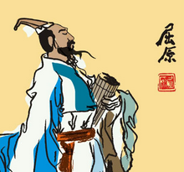
I had great fun on Monday, June 20, 2015. It was a traditional Chinese festival 61 (call) Dragon Boat Festival.
This festival is in memory of Qu Yuan, one of the greatest Chinese poets. He killed himself by 62 (jump) into the Miluo River on May 5th of the lunar calendar(阴历) ，278 BC. People rowed(划) their boats to 63 _ (save)him. But it was too late. They were very sad and then threw rice into the river to feed the fishes 64 that they would not eat his body. From then on, every year on that day, people enjoy eating Zongzi which is made of rice , meat, eggs and so on. In the past, we used 65 (eat) it once a year, but now we
班 级
姓 名
考试号
座位号
regarded(视作) 65 as our daily food. We can eat it whenever we like.
Have you ever 67 (watch) the dragon boat races on TV? It is another important part of this festival. Several teams row their dragon boats as 68 (fast) as they can. The first team to reach the finish line wins.
I wonder 69 you are interested in the Dragon Boat Festival. If you like it, why not come and enjoy it 70 us next year?
61._________ 62._________ 63._________ 64.__________ 65._________
66._________ 67._________ 68._________ 69.__________ 70._________

六、情景交际（本题有5小题，每小题1分，共5分）
根据对话内容，请把A、B、C、D、E字母填入相对应的题项空格中。
A: Excuse me. 71.______________________
B: Well, go along Central Street, and take the second turning on the right.72.________________________
A: 73. ______________________
B: It’ll take you about half an hour to walk there.
A: 74.______________________
B: Yes, you can.
A: 75. ______________________
B: The No. 105 bus. The bus stop is over there.
A: Thank you.
B: You’re welcome.

A. Then you can see a bookstore around there.
B. How far is it from here?
C. Can I get there by bus?
D. Do you know where I can get a dictionary?
E. Can you tell me which bus I should take?

七、书面表达（共10分）
请从外貌，性格，爱好这几方面描述你几年来的变化，你过去是什么样的，现在发生了什么改变，其中最重要的改变是什么？为什么？（80词左右）。

