西安市第七十一中学2017-2018学年度第一学期
期末考试初二英语试卷
满分：100分 时间：90分钟
姓名： 班级： 座位：
听力部分(20分)
Ⅰ.听句子，选择与其意思相符的图片。（每小题1分，共5分）
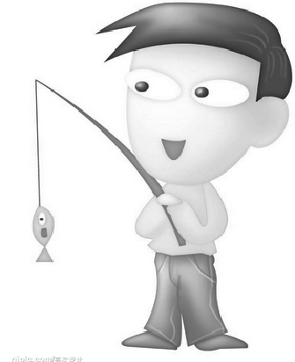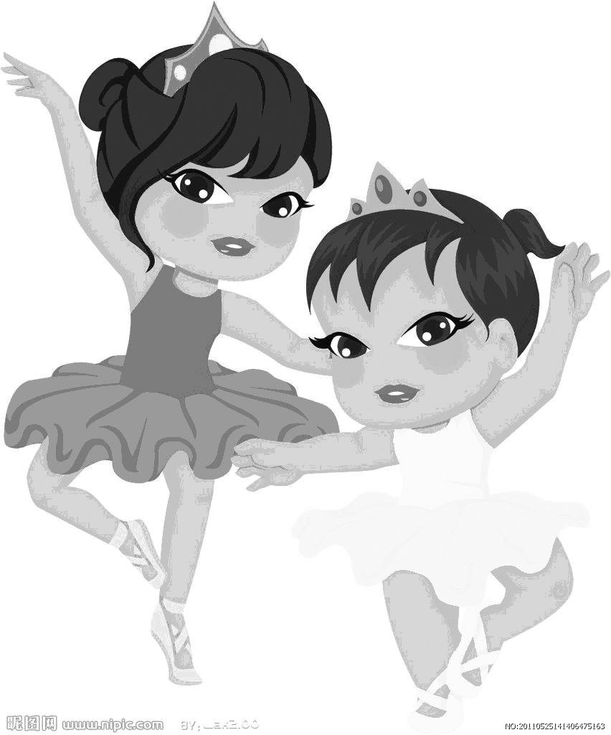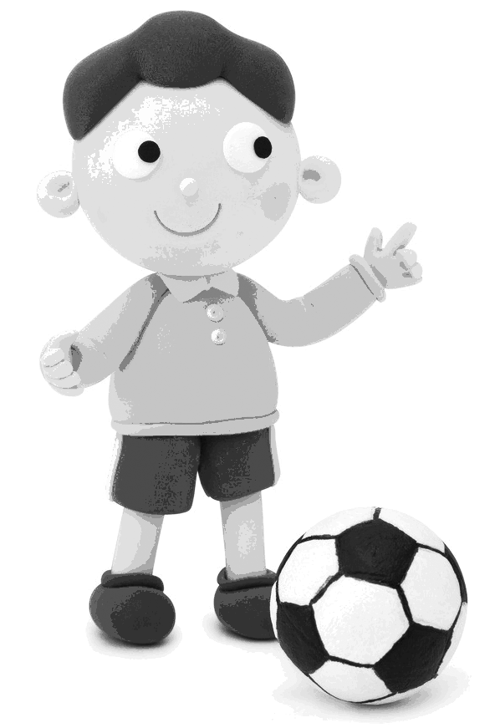
A B C D E
1.__________2.__________3.___________4.__________5. __________
Ⅱ.听短对话，选择正确答案。（每小题1分，共5分）
( )6.What does Sandy want to be?
A.He wants to be a teacher. B.He wants to be an engineer. C.He wants to be a writer.
( )7.Who wants to be a pilot?
A.Jill does. B.James does. C.Bill does.
( )8.What does Helen like ?
A.Music. B.Physics. C. Computer science.
( )9.What does Peter’s sister do?
A.She’s a journalist. B.She’s an editor. C.She’s a college teacher.
( )10.Why does May’s grandpa often do morning exercises?
A.Because he always eats healthy diet.
B.Because he’s friendly to everyone.
C.Because he wants to keep fit.
Ⅲ.听长对话，选择正确答案。（每小题1分，共5分）
听第一段对话，回答第11、12小题。
( )11.What is Mr. Brown doing at the moment?
A. He is having a meeting. B. He is having lunch. C. He is having a rest.
( )12.When will Mr. Johnson call back?
A. At eleven o’clock. B. At one o’clock. C .At three o’clock.
听第二段对话, 回答第13—15小题。
( )13.What did Peter do at the Music Festival last year?
A.He played in the school band.
B.He sang with other students.
C.He helped other students.
( )14.What does Peter really like about the Music Festival?
A.The students have a lot of fun.
B.The students organize the festival by themselves.
C.The teachers help with everything.
( )15.When does the festival start this year?
A. On October 3rd. B. On October 6th. C. On October 7th.
Ⅳ.听短文，选择正确答案。（每小题1分，共5分）
( )16. What is Mike’s job in New York City?
A. A postman. B. A waiter. C. A journalist.
( )17. How did Mike go to San Francisco?
A. By plane. B. By train. C. On foot.
( )18. What did Mike really want to see?
A. The scenery of Italy. B. The scenery of Canada. C. The scenery of the USA.
( )19. When did the train leave New York City?
A. At 10:30 p.m. on Monday. B. At 11:20 p.m. on Friday. C. At 9:30 a.m. on Sunday.
( )20. Why didn’t Mike sleep that night?
A. Because he was angry. B. Because he had many things to do.
C. Because he was excited.
笔试部分（80分）
Ⅰ.完形填空。阅读短文,理解大意,然后从各小题的四个选项中选出一个最佳答案,使短文连贯完整。(共20小题,计20分)
A
The world is divided( 被分成) into two parts. One half of the world is rich and 1 is poor. In the poor part, a lot of people don' I have enough to eat. When they are ill, 2 the hospitals can receive them because they have no enough 3 . In the rich part, a lot of people 4 too much. For example, a dog or a cat in North America eats more than a child in poor countries.
The poor countries have some other difficult problems. Sometimes the land(土地) is too poor to grow 5 on. People there don' I have rich land or enough water. People must make the land better and do a lot of things. The people 6 learn and find water. But rich countries have problems, too. There re not good places to 7 . Sometimes the air is not clean the rivers are too dirty to swim in or drink. The roads and streets are full of people and buses. Cars and buses have to move 8 . Noise is too much. Some people don't have houses. People have to build more houses. People must do something to solve the problems. People must clean the air and the rivers, and they must 9 them clean. 10 we can’t do these things easily.
( )1.A. others B. the other C another D. the other
( )2.A. none of B. all of C. some of D any of
( )3.A beds B. medicine C. time D. money
( )4.A drink B exercise C. eat D. sleep
( )5.A everything B something C nothing D. anything
( )6. A can B. needn’t C must D. may not
( )7. A fall B sleep C. sit D. live in
( )8. A fast B quickly C. slowly D. easily
( )9. A make B. keep C. become D do
( )10. A .And B So C. But D. Because
B
Do you know APEC(亚太经济合作组织)? In 2014, the APEC meeting is held in Beijing. Now, “APEC blue” has become a 11 word. People use it to describe( 描述) the blue 12 during the APEC meetings. To make the air cleaner, people did a lot. These years, 13 pollution is 14 serious in Beijing that people hardly ever see blue skies in such a smog (雾霾) season. After the event, people are wondering how to 15 the APEC blue in the future. Experts give some 16 . First, they believe the environment will be in great danger 17 everyone plays a part in saving the earth. So we don’t think it has 18 to do with you. And what else should we do? Try to walk more and use cars 19 . Finally, make sure factories stop polluting the air. If we can do these things, the sky 20 APEC blue! Hope we can see APEC blue every day!
11. A. popular B. difficult C. simple D. serious
12. A. water B. streets C. sky D. trees
13. A. water B. air C. noise D. soil
14. A. too B. so C. very D. to
15. A. keep B. stop C. stand D. refuse
16. A. idea B. hope C. advice D. information
17. A. if B. but C. though D. unless
18. A. everything B. nothing C. something D. anything
19. A. much B. little C. often D. less
20. A. becomes B. became C. will become D. is becoming
Ⅱ. 阅读理解。阅读下列短文，然后从每小题A、B、C、D四个选项中选出能回答所提问题或完成所给句子的最佳答案 (共15小题，计15分)
A
What are you going to be when you grow up? Last Sunday, I asked my four classmates this question, and here are their answers.
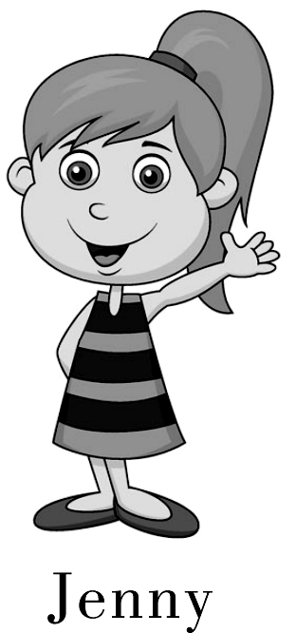 | My hobby is singing. My dream is to be a popular singer like Beyonce. I think I will go to the USA and study music. I hope I will have a chance to meet her and get her autograph (亲笔签名).
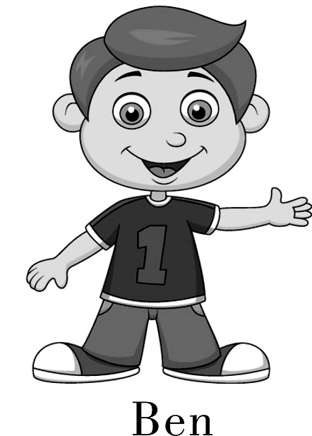 | I think I will be a doctor in eight years. My father is a doctor and my mother is a nurse. They are working in the same hospital.  I think they are so great. They always give a hand to sick people.
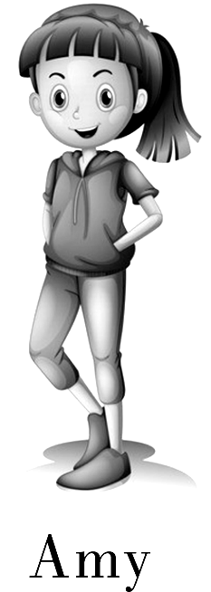 | I think I will be a teacher in five years. I have a deep love for children. Staying with them makes me excited and relaxed. I am outgoing and I am good with children. I think I can be a good teacher.
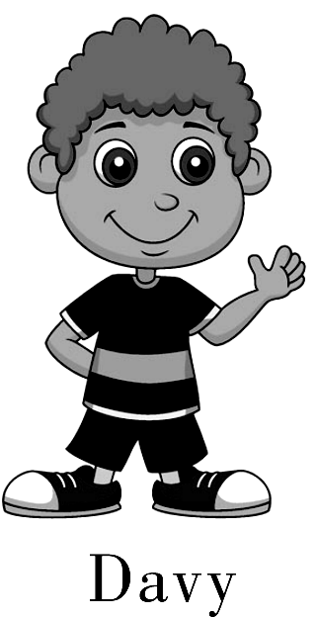 | I want to be a farmer in the future. Maybe it seems strange. But I really enjoy life in the countryside. My favorite game is Happy Farm. I have lots of fun growing vegetables.
21. According to the passage, we can know Beyonce is a ________.
A. pianist B. dancer C. singer D. painter
22. What does the underlined phrase（划线的短语）mean in English?
A. help B. refuse C. leave D. send
23. Who wants to be a teacher?
A. Ben. B. Jenny. C. Amy. D. Davy.
24. Which of the following is TRUE according to (根据) the passage?
A. Ben's parents are both doctors. B. Jenny likes singing very much.
C. Amy doesn't like staying with children. D. Davy doesn’t want to live in the countryside.
25. What are the students talking about?
A. Their future life. B. Their family.
C. Their favorite things. D. Their problems.

B
My problem:
I have two best friends but they dislike each other (彼此). Every time I want to hang out with both of them, they never want to and get angry with me. When I hang out with one but not the other, the other one will get jealous. I want all of us to be good friends, but I don’t know what to do. Somebody help!
Desi, 11, Illinois
Advice:
First you need to ask both of them why they don’t like each other. You should do something to make them like each other again. You can invite both of them to your house at the same time, without telling one the other will be there, too. Leave them alone (单独地) for about 30 minutes. See if they can talk to each other. Hope this helps!
Loren, 11, New York
If they are really your best friends, you should let them know that you like both of them. And they should try to act nicely to each other, because they have the same friend—you!
Laura, 14, Carolina
26. What is Desi’s problem?
A. She doesn’t like the two good friends.
B. Her two good friends can’t be good with each other.
C. She doesn’t want to have two good friends at the same time.
D. She likes one of her good friends better than the other one.
27. Where does Loren come from?
A. Illinois. B. Carolina. C. New York. D. We don’t know.
28. The underlined word “jealous” means “________” in Chinese.
A. 喜爱的 B. 妒忌的 C.骄傲的 D. 谨慎的
29. Which of the following is NOT Loren’s advice for Desi?
A. Find out why they don’t like each other.
B. Do something to make them like each other.
C. Give them a chance (机会) to talk with each other.
D. Tell them you like both of them.
30. From the passage we know________.
A. Desi likes hanging out with both her friends
B. Loren and Laura are Desi’s two best friends
C. Loren and Laura can’t get on well with each other
D. Loren, Candace and Desi are from the same place
C
Teeth are important. Strong , healthy teeth help you chew(咀嚼) foods that help you grow. They help you speak clearly. And yes ,they help you look best. Here are some tips for you to take care of your teeth:
1. Brush your teeth the right way.
Brush your teeth at least twice a day – after breakfast and before bedtime. If you can, brush after lunch or after sweet snacks, too. Brush all of your teeth, not just the front ones. Spend time brushing teeth along the sides and back of your mouth. Spend at least three minutes each time you brush. Play a song you like to help pass the time. Get a new toothbrush every three months. When you buy toothbrush, be sure it has soft bristles(鬃毛).w w w .x k b 1.c o m
2. Learn how to floss(用牙线清洁牙齿) your teeth.
Flossing is a very important way to keep your teeth healthy. Food may hide between two teeth. Flossing can help get rid of it. You’ll need to floss your teeth at least once a day.
3. Have good eating habits.
You need to be careful about what you eat and drink. Eating sugar is a major cause of tooth decay(蛀牙).Eat lots of fruits and vegetables and drink water instead of soda(苏打).新*课标*第*一*网
31. How many times at least should we brush our teeth a day?
A. 1 B. 2 C. 3 D. 4
32. What is the major cause of tooth decay?
A. Not brushing teeth B. Not changing toothbrush
C. Eating sugar D. Drinking water
33. How often should we change our toothbrushes?
A. every three months B. three times a month
C. never D. always
34. The bristles of the toothbrush must be______
A. hard B. soft C. expensive D. cheap
35. Which is the right way to take care of teeth?
A. Only brush front teeth. B. Not brush teeth before sleeping.
C. Drinking more water D. Eat lots of fruits and vegetables and drink water instead of soda.

（非选择性试题）
Ⅲ 完成句子。根据所给汉语，完成句子。每空一词。（共5小题，计10分）
- 由于天气不好，我们看不见下面的任何东西。
_____ ______ the bad weather, we couldn’t see anything below.
2. 事实上，她比我认识的人都幽默。
______ ______, she is funnier than anyone I know.
3.他们提供给大家一个梦想成真的方式。
They give people a way to make their dreams _______ ________.
4.米奇总是时刻准备着要尽自己最大努力。
Mickey was always ready to ______ his _______.
5.他说他有时自己也会犯错。
He said he sometimes _______ ________ himself.
- Ⅳ. 补全对话。(10分) A> 根据对话内容，将方框内符合对话语境的句子抄写在对话空白处，使对话恢复完整。选项中有两项多余。
A: Hi, Michel! Let’s do something on Sunday.
B: Sure. What shall we do?
It’s for kids and it’s boring.
Do you have any ideas?
Let’s meet there at 6:00 p.m.
I don’t love it at all.
At 8:00 p.m. this Saturday.
That sounds good.
Where shall we go?
A: I don’t know. 1 ____________________
B: Why don’t we see a movie?
A: 2 ____________What movie shall we see?
B: Joe Age 4?
A: I don’t love it a lot.
3 __________________ How about Met a Doctor Brown? I hear it’s quite a funny movie.
B: OK. Let’s go to see it. When will it be on?
A: 4 _______________ Shall we have something to eat before the movie?
B: Sure. What about going to the new Italian restaurant?
A: OK. 5 ________________
B: OK. See you!
B> 根据对话的场景，在每个空白处填入一个适当的语句，使对话恢复完整。
A: What are you doing, Mike?
B: I’m watching a TV program about the future.
A: Sounds cool. 1 ________________________________ ?
B: Cities will be more crowded and polluted. There will be less fresh water and the environment will be in great danger.
A: 2_______________________ . Then 3_______________________?
B: We can use less water and plant more trees. Everyone should play a part in saving the earth.
A: Yes, you are right. Will people use money in the future?
B: No, they won’t. 4 ______________________________ .
A: Wow. We don’t need money anymore. 5__________________________ ?
B: No, they won’t. They’ll study at home on computers.
A: Sounds wonderful!
Ⅴ. 任务型阅读。阅读短文，按要求完成文后各小题。（共5小题，计5分）
Do you sometimes find it difficult to communicate (交流) with your parents? The following tips (提示) may help.
- Try to start your talk with something fun. This will make talking easier. For example, ask your parents questions about their day: “How is work?” They love this.
- Make it clear what you want to tell your parents. If they have an opinion (观点), let them finish, and don’t stop them halfway. Ask them to do the same for you.
- Show them your respect (尊敬) by listening to them carefully. Look at them in the eye.
- Be honest (诚实的). Honesty builds trust (信任). Life is good when your parents trust you.
- If your parents don’t understand, that’s ok. They love you and they are trying. Sometimes you need to explain things to them again or in a different way.
- When you finish the talk, remember to thank them for listening. Say something like “Thanks. That really helped.” It will let them know this is important to you, and make them want to do it more often.
1. How many tips does the writer give us? ______________________________
2. Why do we need to look at our parents in the eye when talking with them?
______________________________
3. When our parents don’t understand us, we need to ________________________________
4. 请将划线句子翻译成汉语。
______________________________________________
5. What should we say to thank them when we finish the talk?
______________________________________________

Ⅵ短文填空。（根据短文内容，用方框中单词的适当形式填空，使短文完整、通顺。每个单词只能用一次。计10分）
plan, house, much, prepare, surprise, get, own, they, fun, school
Americans like to have different kinds of parties such as birthday parties, surprise parties, ,tea parties and house-warming parties. Pajama( 睡衣) parties are one of the 1 popular kinds of parties in the US. At a pajama party, a group of friends spend the night at a person’s 2 .It is a great way for children or teenagers to ___3___ together and have a good time.
To hold(举行) a pajama party, the host(主人) will usually 4 some fun activities such as watching movies and playing board games and video games. He or she should also 5 some delicious snacks and fun food like pizza. Guests at a pajama party should bring their 6 pajamas, toothbrushes, pillows(枕头) and blankets(毯子). But if they forget something, they don t need to worry because the host will give 7 something they need.
A pajama party is just for 8 . A prom is different. A prom is a forma(正式的)dance party, and it is a very important thing in most American 9 .The party is usually held near the end of the senior year, the last year of high school, so it is often called graduation（毕业) dance. Students should wear formal clothes at the prom. A Prom Queen(女王) and a Prom King may also be crowned (加冕) at many schools' proms
Do you know parties? If you know about American culture, you won’t be 10
Ⅶ 书面表达。（10分）
假如你叫Dick。想要邀请John参加你的生日聚会。请根据提示内容写一封邀请函。
时间：1月28日，周日晚上7点整。地点：成驿酒店 三峡厅 。
活动：唱歌、聚餐、看电影、聊天。 其它人员：Ben，Sam，Grace，Sarah.
要求：
1. 不低于60词, 开头已经给出，不计入总词数。
2. 文中不得使用本人姓名及学校名称。
3. 提示内容翻译时都要涉及。运用短语、句法正确。

